**Lab Manual- Create Sample DotNet MVC Web App and Store in Github**

**Prepared for**:

**Date:** 18th Nov 2018

**Prepared by:** Aditi Shrivastava

Document Name: Lab Manual

**Document Number** SysOpsLab312

**Contributor:**

Table of Contents

1 OBJECTIVE 3

2 PRE-REQUISISTE 3

3 Create an ASP.NET Core MVC Application 3

3.1 **Create your app** 4

3.2 **Build and Run Your App** 7

3.3 **Update Your App** 9

4 Push the Code to Source Code Repository (Github) 11

4.1 **Create a Repo in Github** 11

4.2 **Initialize Local Repo and Push the code to Github** 12

5 Update the Code and Push again to Repository (Github) 15

5.1 **Update Your App** 15

# OBJECTIVE

In this Lab, we will discuss how we can create a HelloWorld app with ASP.NET Core 3.1 using Visual Studio Code. We will learn how to create an ASP.NET Core MVC application, how to create a new Controller, how to create a new View, and how to run the HelloWorld app, etc.

# PRE-REQUISISTE

* Accounts in Azure
* A local Computer with 4 CPU, 16 GB RAM, 200 GB disk space
* .NET Core 3.1 SDK
* Visual Studio Code

# Create an ASP.NET Core MVC Application



## **Create your app**

A simple application written in C# that prints Hello, World! to the consol

Create a directory in DOS Console and also go inside it

**Md mvcdemo**

**Cd mvcdemo**

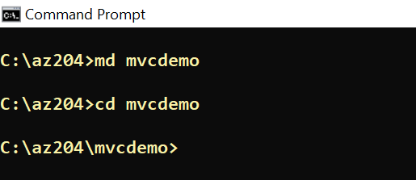

* In your command prompt, run the following command to create your app:

**dotnet new mvc -o MVCDemoApp**

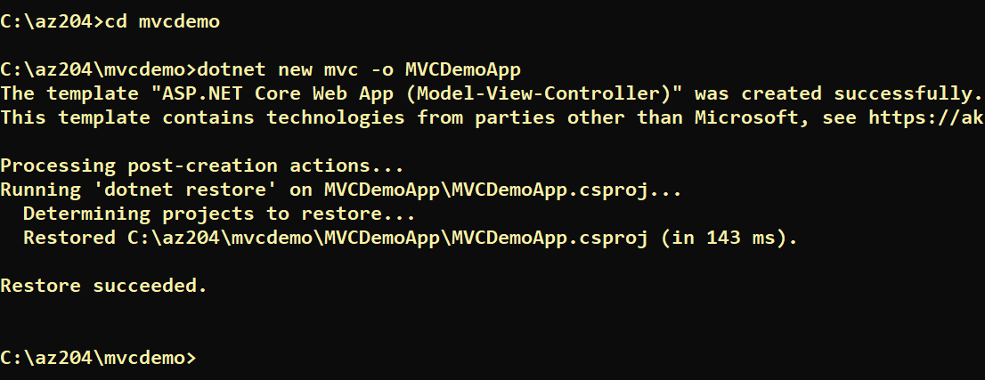

**[Note ] What do these commands mean?**

**The dotnet new MVC**  command creates a **new** “**ASP.NET** Core **MVC** Web Application”, the application contains basic boilerplate files and directory. Then, navigate to the new directory created by the previous command:

* In your command prompt, run the following command to go inside newly created App

cd MVCDemoApp

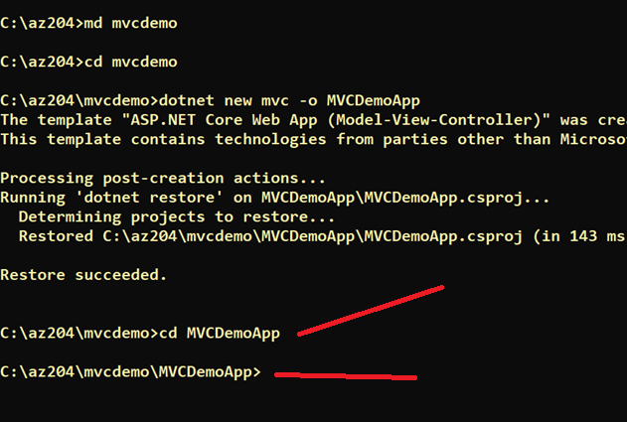

* Now open **Code .** to Launc VS Code Editor

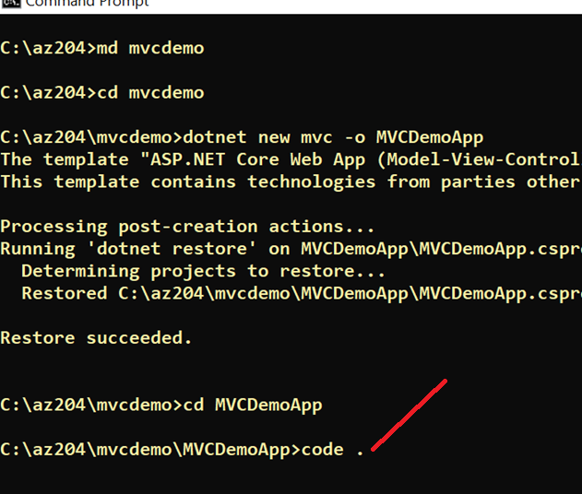

* It Open the project in VS Code Editor

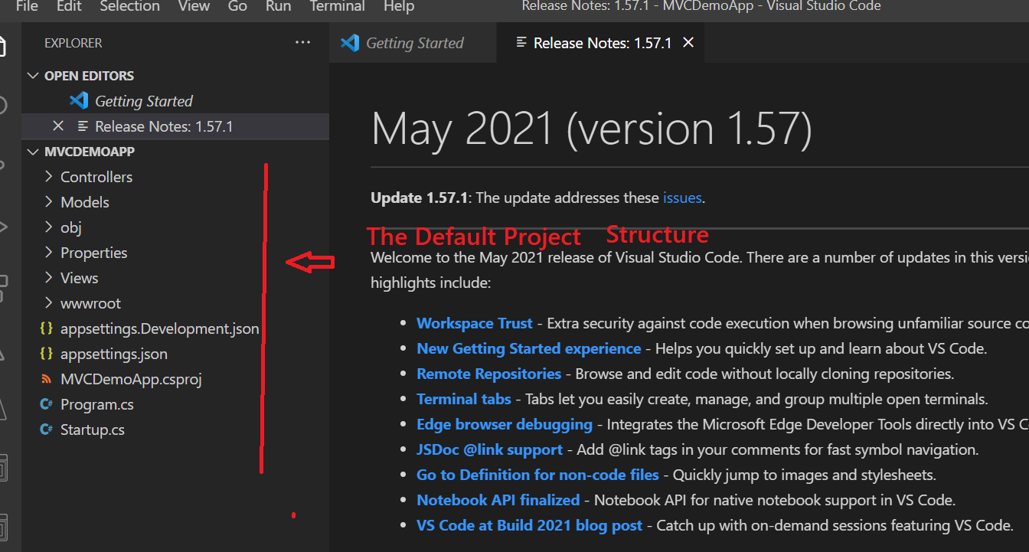

* Now go to Terminal and Click new terminal

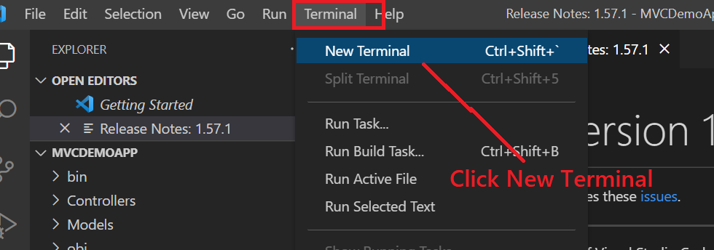

* You Can also see the projectd details

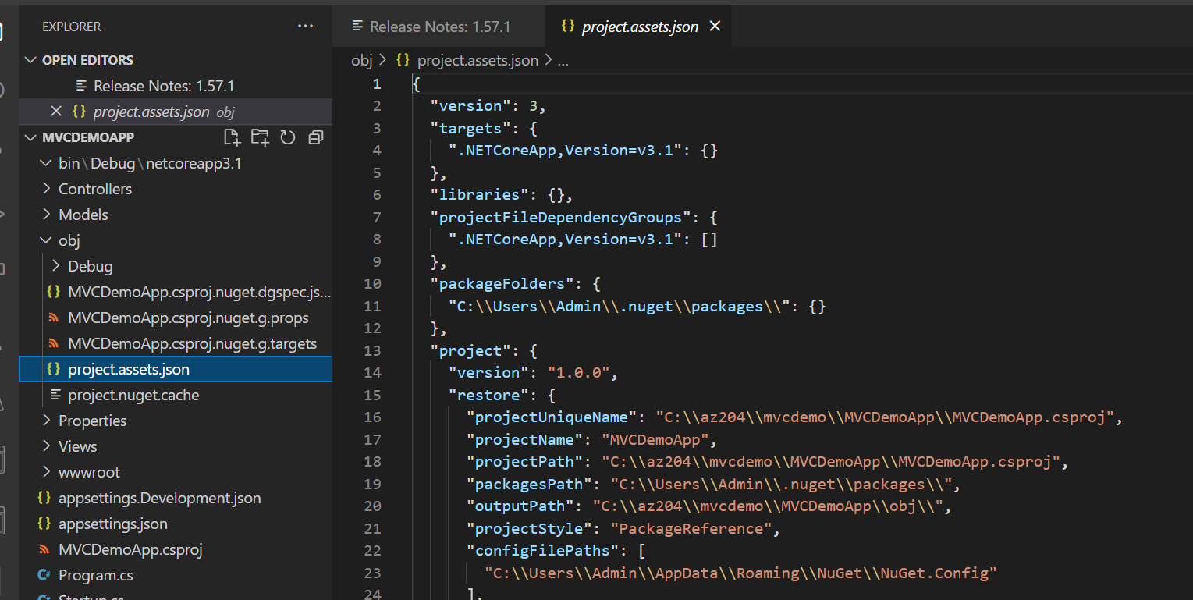

* The main file in the**MVCDemoApp** folder is **View\home\index.cshtml** By default, it already contains the necessary code to write "**Hello World!"** to the Console.

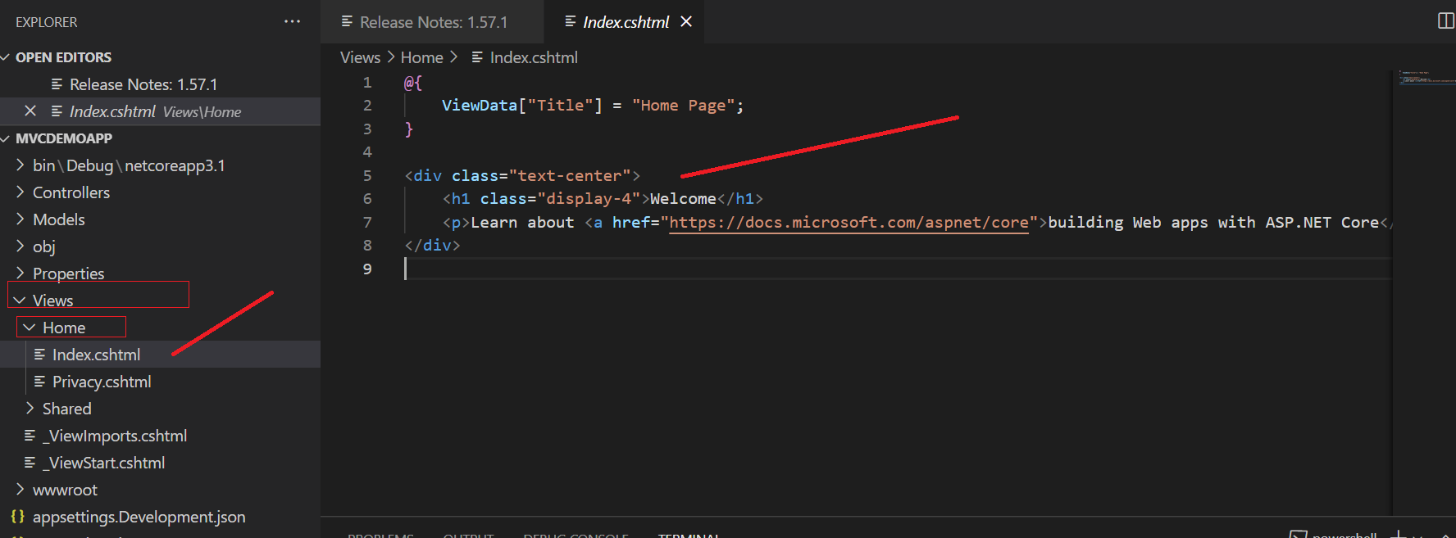

## **Build and Run Your App**

* Now we are going to Build the program (Build compiles the source code into a (hopefully) runnable application)

Dotnet Build

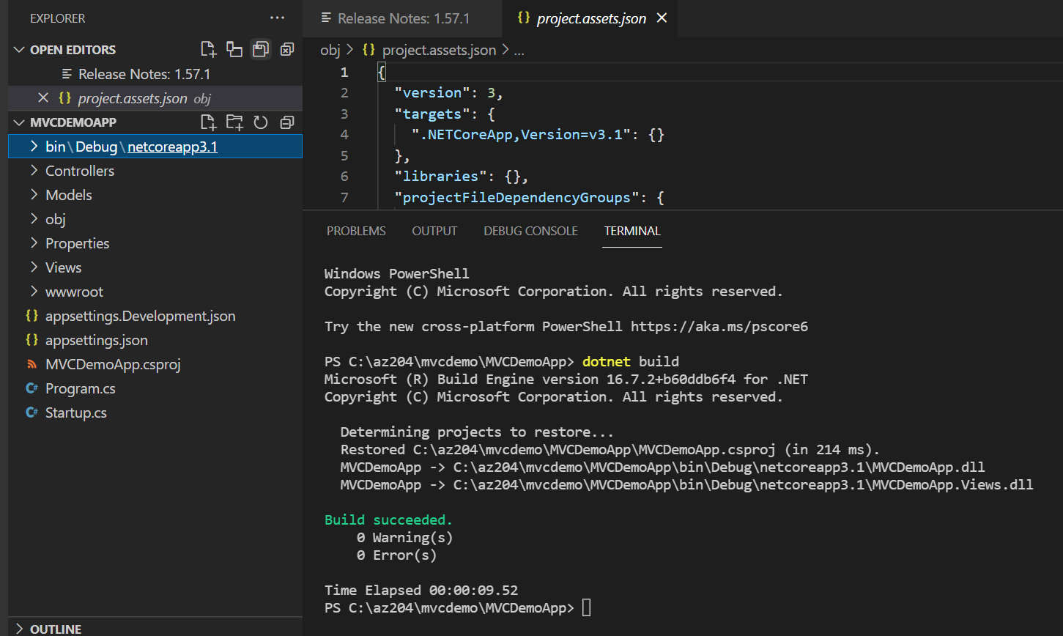

* In your command prompt, run the following command:

DotNet Run

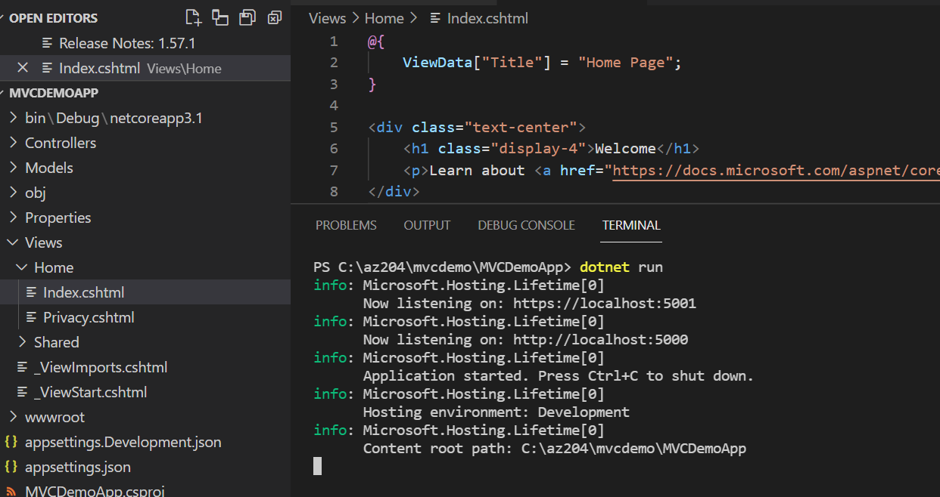

* Now you see it show the URL like <http://localhost:5001> , just launch it in browser and You will see the default browser. You May get the certificate effort so just ignore it.

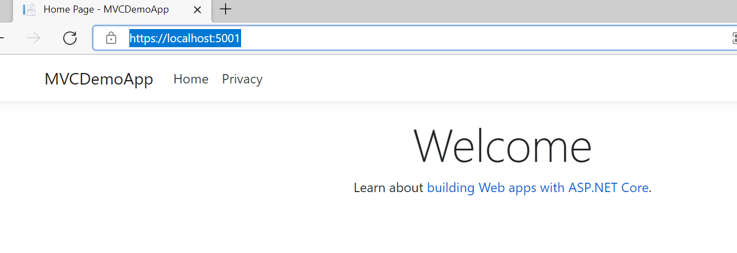

## **Update Your App**

Now lets make small changes in code. For that we go to Program.cs and add some line in Println statement

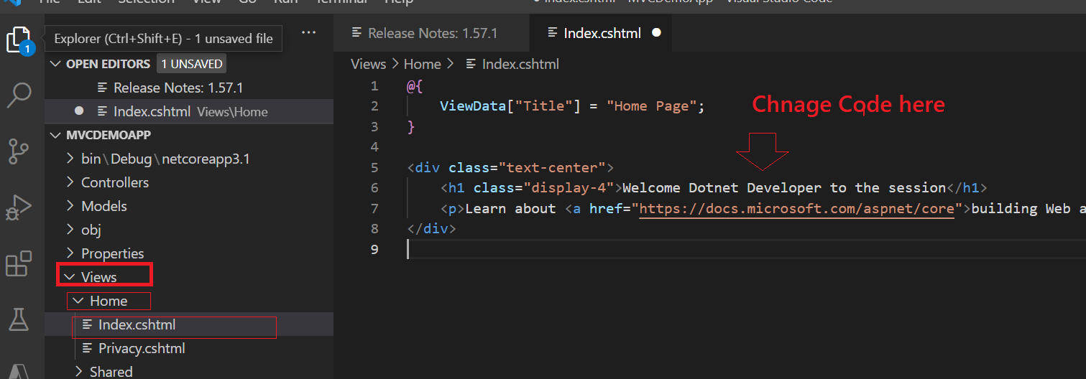

Now save **– File 🡪 Save All**

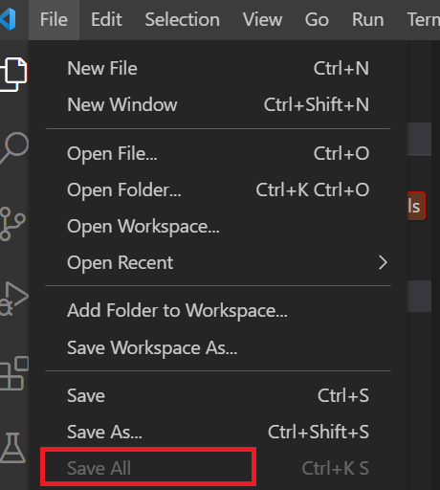

Press **CTRL+C** to end the running server

Now again Build and Run the Code.

**DotNet Build**

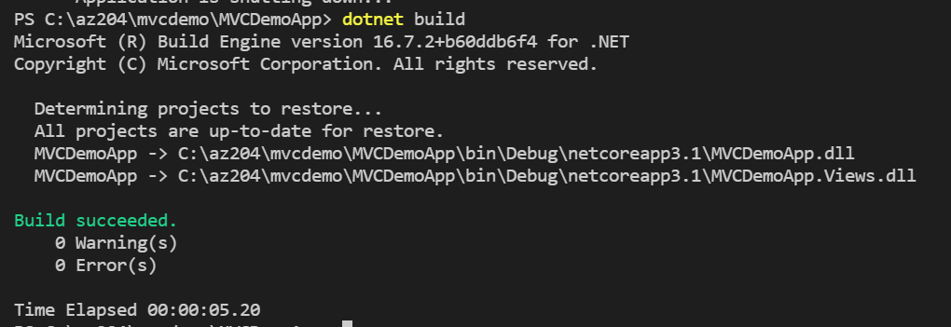

**DotNet Run**

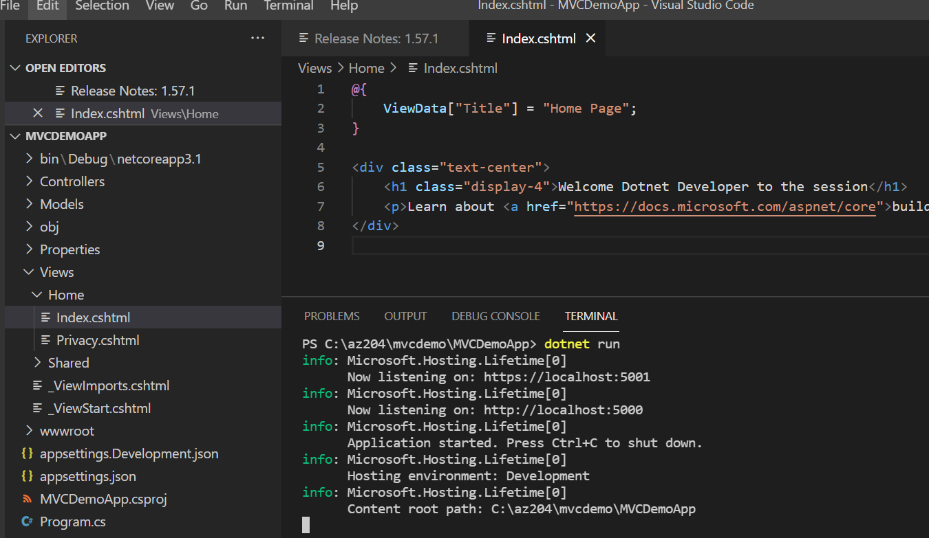

**Now Refresh the web**

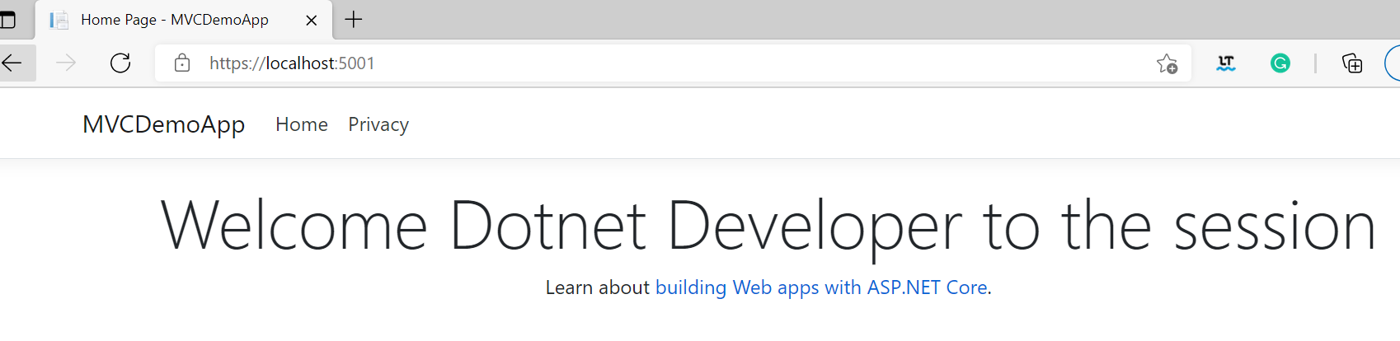

# Push the Code to Source Code Repository (Github)



## **Create a Repo in Github**

* Goto Github and click New Repo
* Type the Reponame as **MVCDemoApp**
* Type some description
* Without clicking the any other check box

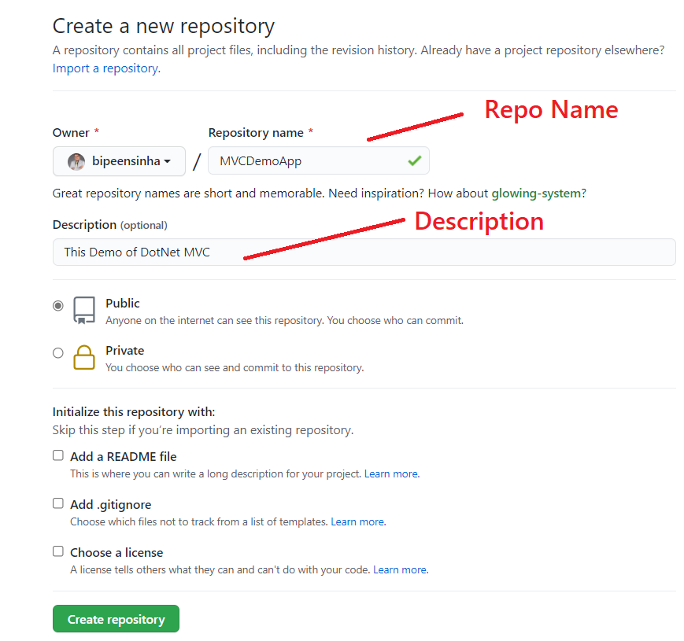

* Click **Create Repository**

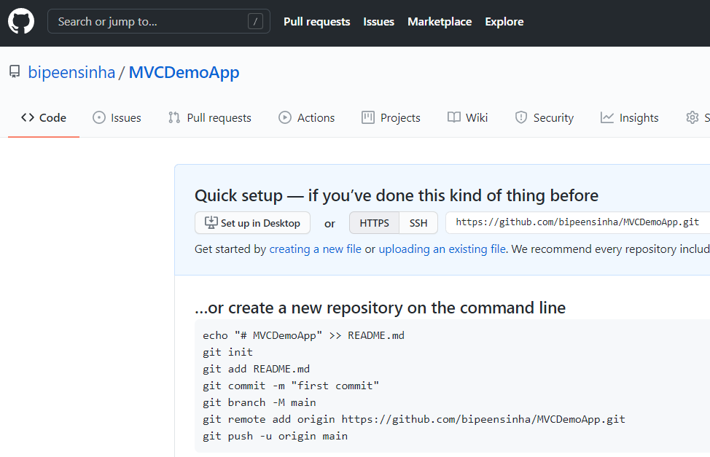

## **Initialize Local Repo and Push the code to Github**

* On the local VS Code terminal type below command

**Git Init**

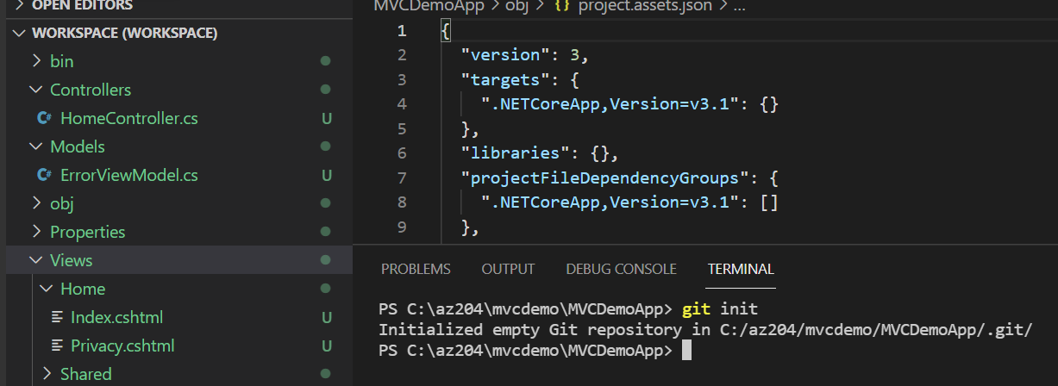

* Now add the code to git Quue with git add . ( where . (dot) represent everything in current directory)

**Git add .**

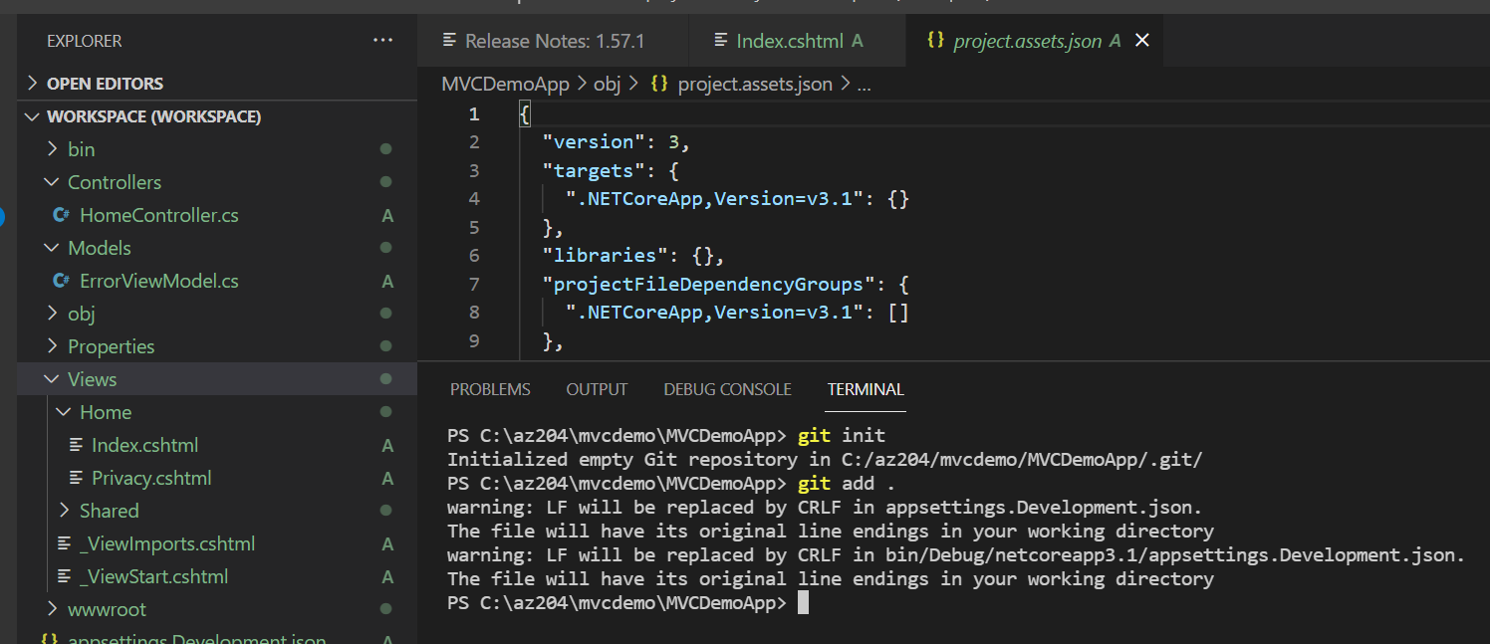

* Now copy the git remote orgin command from github and past it here. It is going to tel your git agent installed your laptop that which repo to push the code

**git remote add origin https://github.com/bipeensinha/myapp.git**

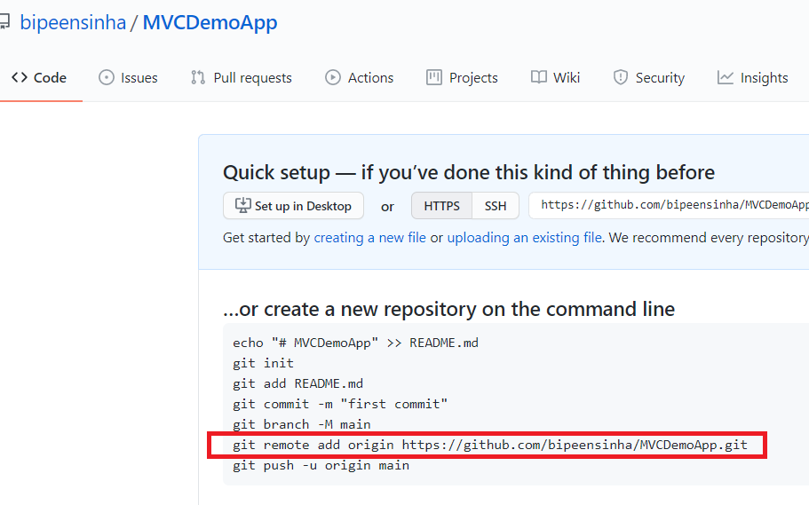

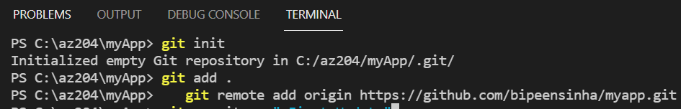

* Now commit the code to Github queue

**git commit -m "first commit"**

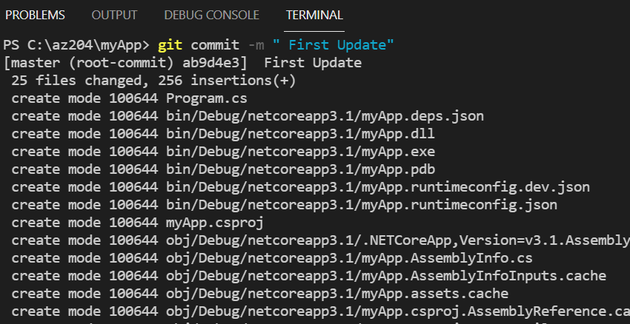

* Now Push the code to Github Repository

**git push –all**

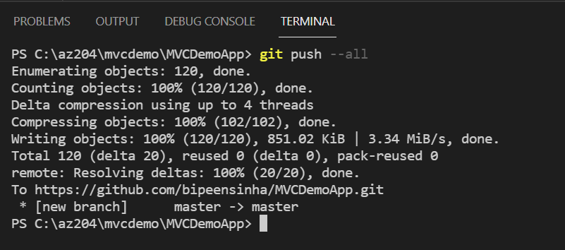

* Now go to github Portal , Refresh it and check you have your code there.

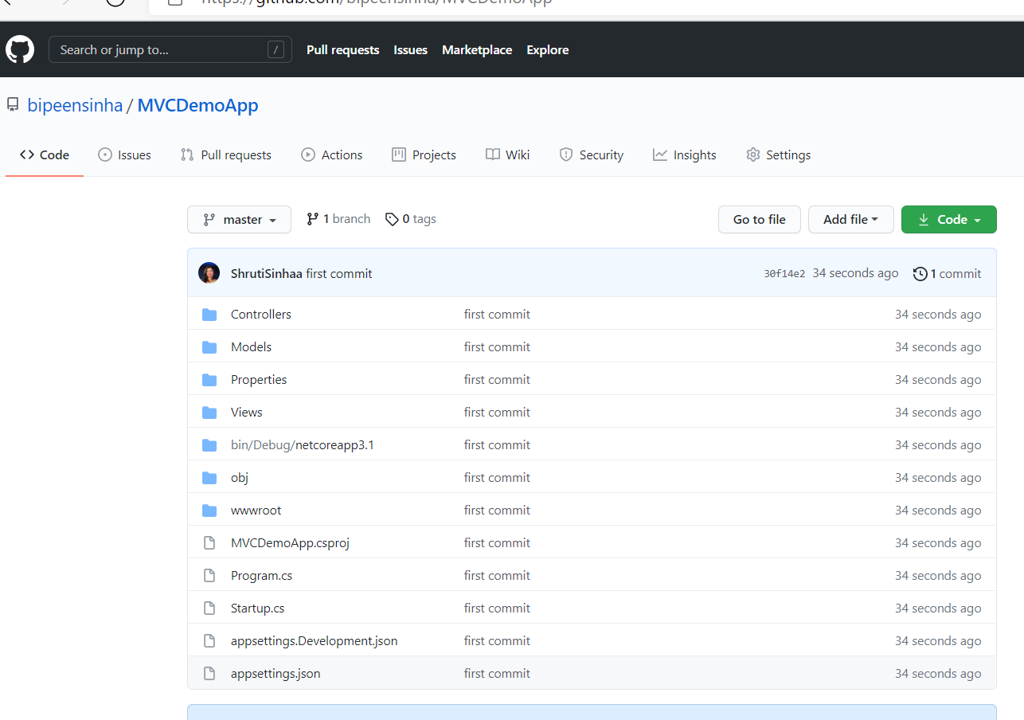

# Update the Code and Push again to Repository (Github)

## **Update Your App**

Now lets make small changes in code. For that we go to Program.cs and add some line in **Println statement**

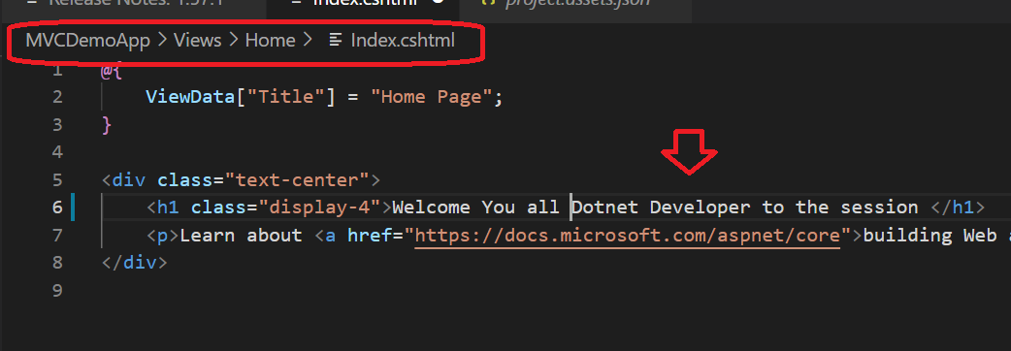

Now save **– File 🡪 Save All**



Now again Build Code.

**DotNet Build**

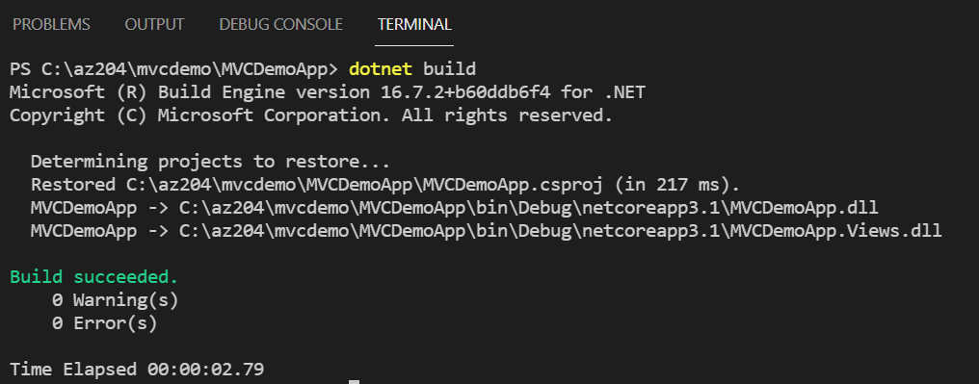

* Now add the code to git Quue with git add . ( where . (dot) represent everything in current directory)

**Git add .**

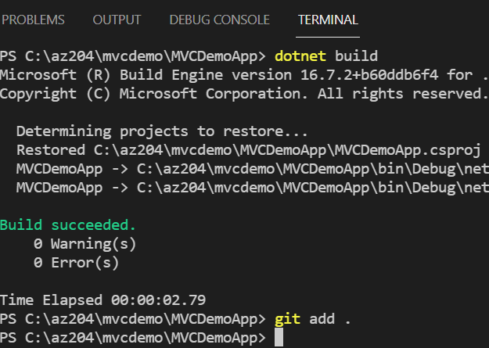

* Now commit the code to Github queue

**git commit -m "Second commit"**

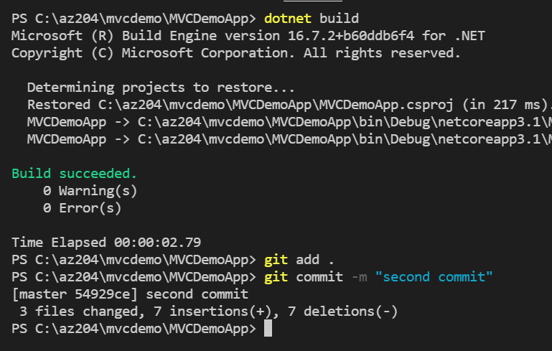

* Now Push the code to Github Repository

**Git push --all**

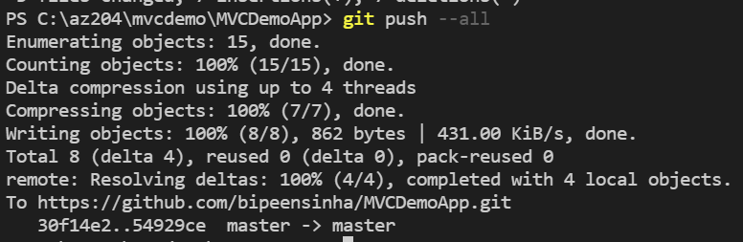

* Now go to github Portal, Refresh it and check you have your code there.

